Lawrence North
Performing Arts Newsletter

Week of 12/9 – 12/14/19

Click here to view our calendar of events for the 2019 – 2020 school year
Follow us on Facebook, Instagram, and Twitter

HOLIDAY CONCERT – THIS WEEKEND!
For the first time ever, LN will showcase ALL of our Performing Arts students together in ONE amazing concert! Our students and staff have been working hard to make our inaugural show a success, and we would love to have all of you there with us! Tickets can be purchased online at lnpad.ludus.com, or in the Performing Arts office anytime during school hours. Contact Jen Jansen at jenniferjansen@msdlt.k12.in.us with any questions or concerns about your order.

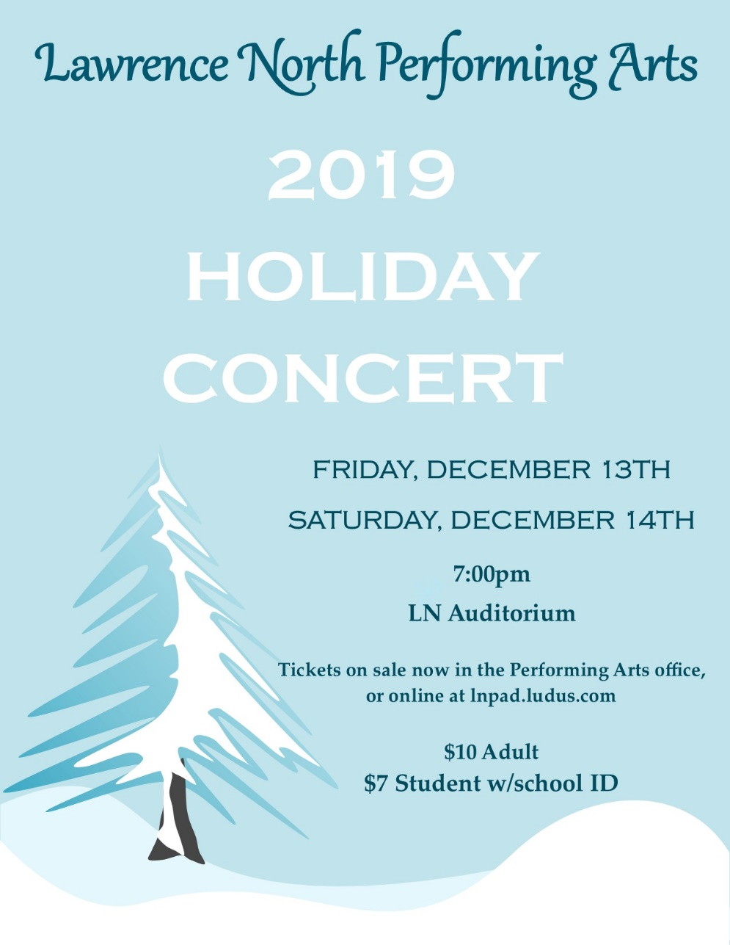

GOSPEL CHOIR COMMUNITY OUTREACH
Our Sounds of Praise Gospel Choir students are multi-faceted; not only do they perform in concerts at LN, but also for various churches and organizations around the Indianapolis community.

Directed by Cliff Latham, this group has traveled as far as Indiana State University, where they performed as part of the Charles E. Brown Black History Gospel Celebration. More frequently, Sounds of Praise has performed for church congregations throughout the greater Indianapolis area. Their most recent performance was this past Sunday, at Castleton Church of the Nazarene.

Pictured above: Sounds of Praise Gospel Choir, at Castleton Church of the Nazarene (Photo credit: Chaevon Latham)

DANCE TEAM COMPETITION SATURDAY
The LN Dance Team begins its competitive season this Saturday, December 14th, at Kokomo High School. Performance times are provided below, come out and support our students in their first competition of the year! Tickets will be sold at the door, and are $7 for adults, $5 for students/seniors, Free for children 2 and under.
Performing in the Solo Division:
Colette Shea - 8:42am
Haylee Sexson - 10:50am
Caroline Eads – 11:14am
Team Performance, Hip Hop Division: 2:54pm
Team Performance, Jazz Division: 4:29pm

Pictured above: LN Dance Team (Photo credit: Chaevon Latham)

WINTER PERCUSSION SEASON IN FULL SWING
The Lawrence Township Winter Percussion ensemble will be celebrating it’s 5th season this year, and students are already hard at work to make it a success!

Pictured above: LT Winter Percussion students (Photo credit: Alex Entin)

UPCOMING EVENTS
Friday, December 13th & Saturday, December 14th – Holiday Concert, in LN Auditorium
Saturday, December 14, 2019 – Dance Team Competition @ Kokomo High School
Saturday, January 11, 2020 – Dance Team Competition @ Mt. Vernon High School
Saturday, January 18, 2020 – Dance Team Competition @ Avon High School
Tuesday, January 28, 2020 – Show Choir Preview Show, in LN Auditorium
Saturday, February 1, 2020 – Show Choir Competition @ Fishers High School

REACH OUT TO US
Dave Morton, Performing Arts Department Chair davidmorton@msdlt.k12.in.us
Connor Vaughn, Director of Bands connorvaughn@msdlt.k12.in.us
Dan Herrick, Assistant Band Director danielherrick@msdlt.k12.in.us
Libby Warrner, Choir Director elizabethwarrner@msdlt.k12.in.us
Chaevon Latham, Dance Director chaevonlatham@msdlt.k12.in.us
Jose Valencia, Orchestra Director josevalencia@msdlt.k12.in.us
Kameron McBride, Theatre Director kameronmcbride@msdlt.k12.in.us
Alex Entin, Percussion Director alexanderentin@msdlt.k12.in.us
Jennifer Jansen, Performing Arts Administrative Assistant jenniferjansen@msdlt.k12.in.us

